GDP - National Income Accounts

Topic 1: Circular Flow

Difficulty Level 2
- In a simple circular-flow diagram, households _______ goods and services and _______ factors of production.
  - buy; buy
  - buy; sell
  - sell; sell
  - sell; buy
  - barter; sell
- According to the circular flow model, which of the following statements is true?
  - Households are demanders in both the factor and product markets.
  - Households are demanders in the product markets and suppliers in the factor markets.
  - The government is a demander in the product market but not in the factor market.
  - Firms are demanders in the product market in suppliers in the factor markets.
  - Firms are suppliers in both the factor and product markets.
- Which of the following is NOT a part of a household’s income?
  - wages
  - savings
  - profit
  - rent
  - interest
Use the diagram below to answer the following questions.
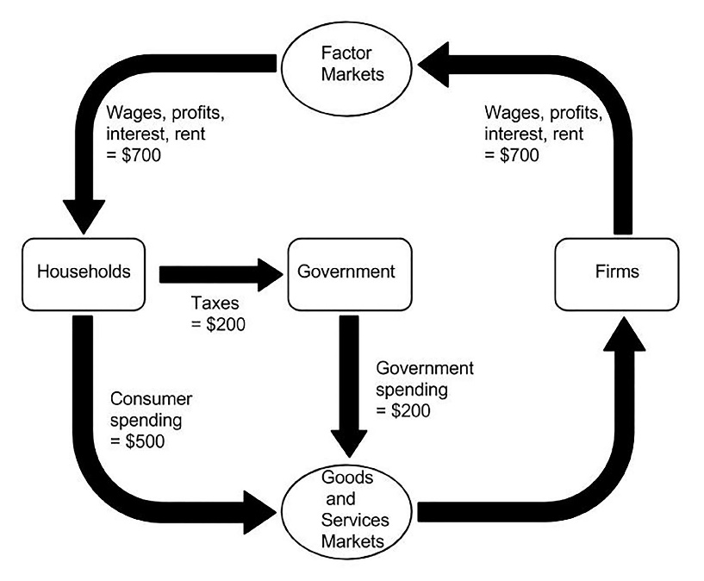
- According to the circular flow diagram, how does the government fund its spending?
  - Consumer spending
  - Sales of factor resources
  - Profit
  - Taxes
  - Sales of goods and services
- According to the circular flow diagram, what is the GDP in this economy?
  - $200
  - $500
  - $700
  - $1200
  - $1600
- According to the circular flow diagram on the next page, what is the GDP in this economy?
  - $725
  - $800
  - $875
  - $900
  - $1600

Difficulty Level 3
- Which of the following economic behaviors is considered to be a leakage from the circular flow model?
  - saving
  - consumption spending
  - investment spending
  - government spending
  - imports
Use the diagram below to answer the following questions.
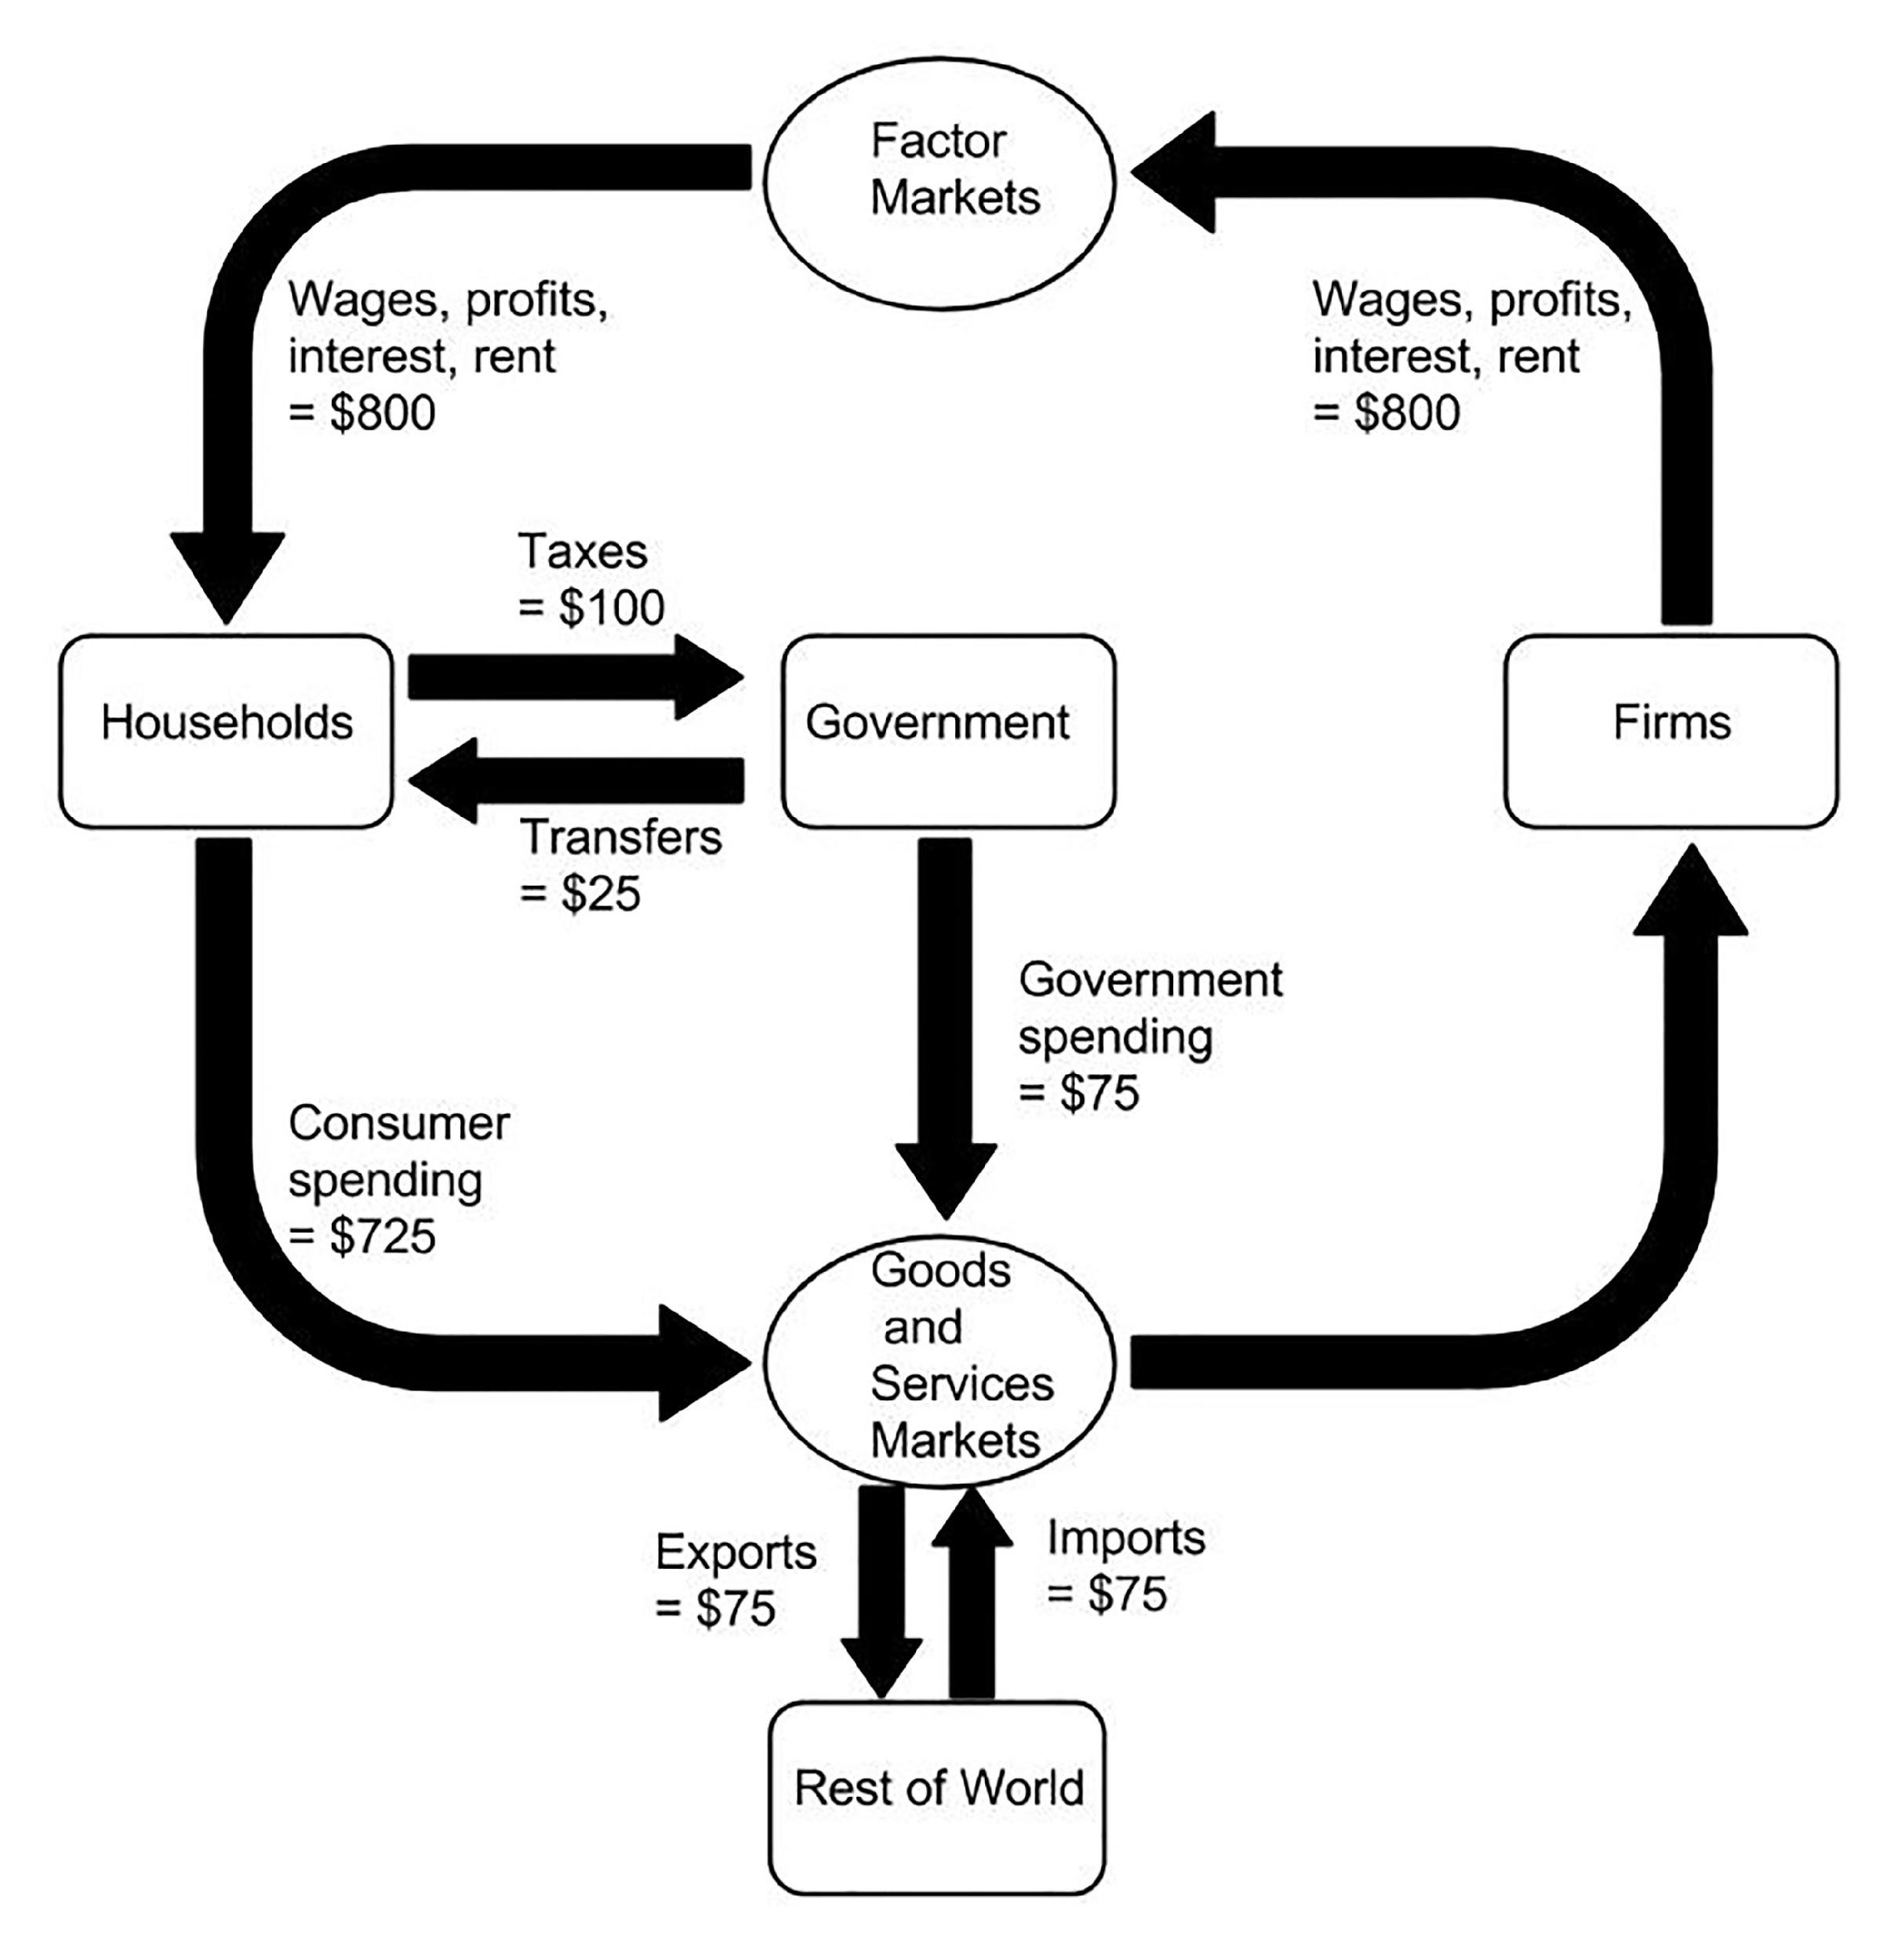

- According to the circular flow diagram, which of the following statements is true?
- A household’s income equals its expenditures.
- The government’s income equals its expenditures.
- Net exports are equal to $75.
1 | B | 6 | B
2 | B | 7 | A
3 | B | 8 | C
4 | D | 9
5 | C | 10

  - II only
  - III only
  - I and II only
  - I, II, and III

